

Ian & Penny invite you to join them at their
EASTER 2027
Sequence dance Break
(Including Ian & Penny’s ‘Easter Ball’)

Held at the beautiful 4* The Abbey Hotel, Great Malvern, Worcestershire

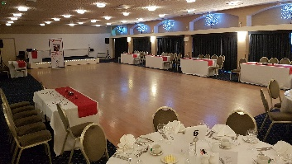
Enjoy dancing your favourite Sequence Dances and making new friends
at this fabulous 3-night sequence dance break.

Saturday 27th March to Tuesday 30th March 2027
3 Nights on Half Board (Breakfast & Evening Meal included)

from only £360.00 per person
(Based on 2 Adults sharing a Standard Double Room)
Room Upgrade Supplements for the whole 3 night break (subject to availability):-
Superior Double or Twin at £60.00 per room
Executive Double at £150.00 per room / Club Double at £180.00 per room

A non-refundable deposit of £100.00 per person is required at time of booking.
The balance payment is due to be paid by Friday 29th January 2027.

Saturday 27th March 2027
Arrive at The Abbey Hotel for check-in from 3pm
Welcome Gift in your room upon arrival with our compliments
A La Carte Evening Meal included, served in the Priory View Restaurant
Ian & Penny’s Welcome Dance Date, enjoy an evening of Sequence Dancing
Evening Dress Code is Smart Casual

Sunday 28th March 2027
Breakfast Included
This morning, Sequence Dance Class with Ian & Penny
Afternoon at leisure to relax or enjoy the surrounding areas
Private Drinks Reception, enjoy a glass of Bubbles with our compliments.
Evening Gala Meal included, served in The Elgar Suite Ballroom
Ian & Penny’s ‘Easter Ball’, enjoy an evening of Sequence Dancing
Evening Dress Code – Formal / Dress to impress

Bank Holiday Monday 29th March 2027
Breakfast Included
This morning, Sequence Dance Class with Ian & Penny
Afternoon at leisure to relax or enjoy the surrounding areas
A La Carte Evening Meal included, served in the Priory View Restaurant
Ian & Penny’s Farewell Dance Date, enjoy an evening of Sequence Dancing
Evening Dress Code is Smart Casual

Tuesday 30th March 2027
Leisurely Breakfast included before exploring your surrounding areas or heading home.

Contact Ian & Penny for a booking form & payment details

Email:- ian.penny@yes2danceclasses.co.uk
Call:- 07505 382181
*It is strongly recommended that you have travel insurance in case you have to cancel*

