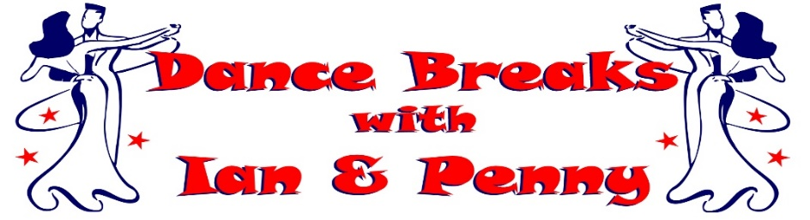
Ian & Penny invite you to join them at their
MAY 2024 BANK HOLIDAY DANCE BREAK
‘IAN’S BIG BIRTHDAY BASH’
(Including ‘Ian’s 60th Birthday Celebration Ball’)
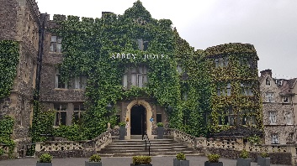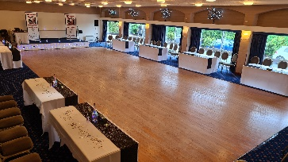

Join us at the beautiful 4* The Abbey Hotel, Great Malvern in Worcestershire
Saturday 4th May to Tuesday 7th May 2024
(Enjoy a Bank Holiday break without driving on Bank Holiday Monday)
3 Nights on Half Board (Breakfast & Evening Meal included)

from only £325.00 per person
(Based on 2 Adults sharing a Standard Double)

Room Upgrade Supplements for the whole 3 night break (subject to availability):-
Sole Occupancy (based on Standard Double) at £60.00 per room
Superior Double or Twin at £45.00 per room
Executive Double at £135.00 per room / Club Double at £165.00 per room

A non-refundable deposit of £75.00 per person plus any room upgrade supplement is required at time of booking. The non-refundable balance payment is due to be paid by Friday 8th March 2024

Saturday 4th May 2024
Arrive at The Abbey Hotel, Great Malvern for check-in from 3pm
Welcome Gift in your room upon arrival with our compliments
Evening Meal included, served in the Priory View Restaurant
Ian & Penny's Welcome Dance Date (Ballroom, Latin & Popular Sequence)
Evening Dress Code - Smart Casual

Sunday 5th May 2024
Breakfast Included
Morning Dance Workshop with Ian & Penny
Afternoon at leisure to relax or enjoy the surrounding areas
Private Drinks Reception, enjoy a glass of Bubbles with our compliments
Evening Gala Meal included, served in The Elgar Suite Ballroom
‘Ian’s 60th Birthday Celebration Ball’ (Ballroom, Latin & Popular Sequence)
Evening Dress Code – Formal / Dress to impress in your most stylish outfits

Bank Holiday Monday 6th May 2024
Breakfast Included
Morning Dance Workshop with Ian & Penny
Ian’s Birthday Party in the Elgar Suite Ballroom
Afternoon at leisure to relax or enjoy the surrounding areas
Evening Meal included, served in the Priory View Restaurant
Ian & Penny's Farewell Dance Date (Ballroom, Latin & Popular Sequence)
Evening Dress Code - Smart Casual

Tuesday 7th May 2024
Leisurely Breakfast included before exploring your surrounding areas or heading home

Contact Ian & Penny for a booking form & payment details
Email:- ian.penny@yes2dancebreaks.co.uk or Call:- 07505 382181
*It is strongly recommended that you have travel insurance as all payments are non-refundable*

