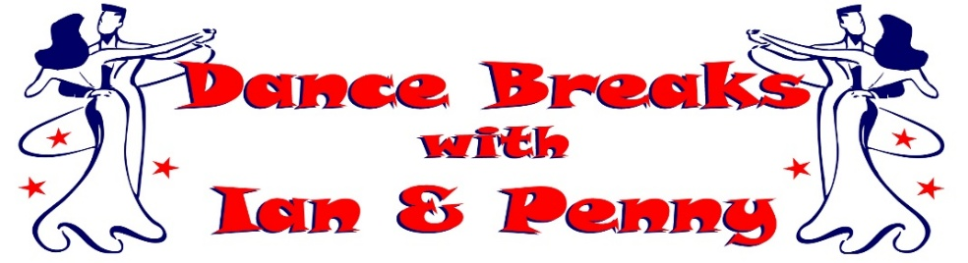
Ian & Penny invite you to join them at their
May 2027 BANK HOLIDAY DANCE BREAK
(Including Ian & Penny’s ‘Spring Colours Ball’)

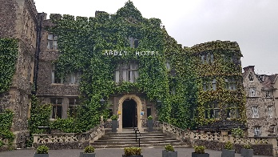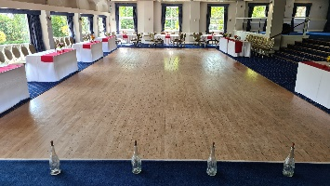

Join us at the beautiful 4* The Abbey Hotel, Great Malvern in Worcestershire
Saturday 1st May to Tuesday 4th May 2027
(Enjoy a Bank Holiday break without driving on Bank Holiday Monday)
3 Nights on Half Board (Breakfast & Evening Meal included)

from only £360.00 per person
(Based on 2 Adults sharing a Standard Double)

Room Upgrade Supplements for the whole 3 night break (subject to availability):-
Sole Occupancy (based on Standard Double) at £60.00 per room
Superior Double or Twin at £60.00 per room
Executive Double at £150.00 per room / Club Double at £180.00 per room

A non-refundable deposit of £100.00 per person is required at time of booking.
The balance payment is due to be paid by Friday 5th March 2027.

Saturday 1st May 2027
Arrive at The Abbey Hotel, Great Malvern for check-in from 3pm
Welcome Gift in your room upon arrival with our compliments
Evening Meal included, served in the Priory View Restaurant
Ian & Penny's Welcome Dance Date (Ballroom, Latin & Popular Sequence)
Evening Dress Code - Smart Casual

Sunday 2nd May 2027
Breakfast Included
Morning Dance Workshop with Ian & Penny
Afternoon at leisure to relax or enjoy the surrounding areas
Private Drinks Reception, enjoy a glass of Bubbles with our compliments
Evening Gala Meal included, served in The Elgar Suite Ballroom
Ian & Penny's ‘Spring Colours Ball’ (Ballroom, Latin & Popular Sequence)
Evening Dress Code – Formal / Dress to impress in your most colourful outfits

Bank Holiday Monday 3rd May 2027
Breakfast Included
Morning Dance Workshop with Ian & Penny
Afternoon at leisure to relax or enjoy the surrounding areas
Evening Meal included, served in the Priory View Restaurant
Ian & Penny's Farewell Dance Date (Ballroom, Latin & Popular Sequence)
Evening Dress Code - Smart Casual

Tuesday 4th May 2027
Leisurely Breakfast included before exploring your surrounding areas or heading home.


Contact Ian & Penny for a booking form & payment details
Email:- ian.penny@yes2dancebreaks.co.uk or Call:- 07505 382181
*It is strongly recommended that you have travel insurance as all payments are non-refundable*

