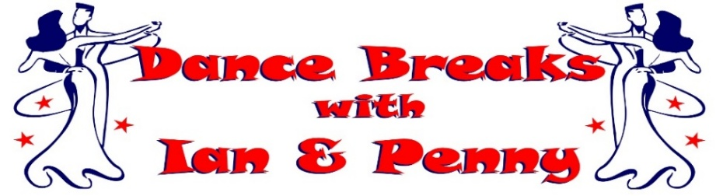
Ian & Penny invite you to join them for lots of fun &
dancing as they get ready for Christmas at their
November 2027 ‘tango & tinsel’ FESTIVE dance break

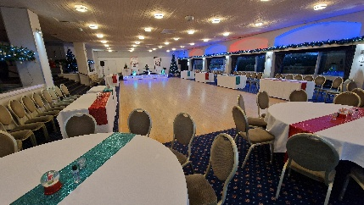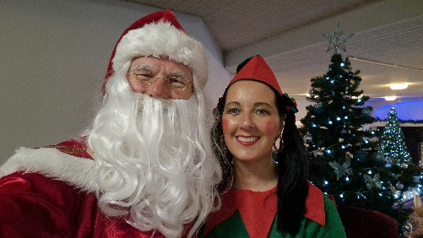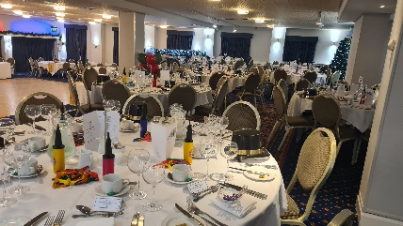
Join us at the beautiful 4* The Abbey Hotel, Great Malvern in Worcestershire
Friday 26th November to Monday 29th November 2027
3 Nights on Half Board (Breakfast & Evening Meal included)

from only £395.00 per person
(Based on 2 Adults sharing a Standard Double)

Room Upgrade Supplements for the whole 3 night break (subject to availability):-
Sole Occupancy (based on Standard Double) at £60.00 per room
Superior Double or Twin at £60.00 per room
Executive Double at £150.00 per room / Club Double at £180.00 per room

A non-refundable deposit of £100.00 per person is required at time of booking.
The balance payment is due to be paid by Thursday 30th September 2027.

Friday 26th November 2027 - Our Christmas Eve
Arrive at The Abbey Hotel, Great Malvern for check-in from 3pm
Welcome Gift in your room upon arrival with our compliments
Evening Meal included, served in the Priory View Restaurant
Ian & Penny's Christmas Eve Dance (Ballroom, Latin & Popular Sequence)
Evening Dress Code - Smart Casual

Saturday 27th November 2027 - Our Christmas Day
Breakfast Included - Lets Imagine its Christmas Morning!
Christmas Morning Dance Workshop with Ian & Penny
Light Christmas Lunch followed by carol singing, visit from Santa, fun, games and more!
(Christmas jumpers encouraged - special prizes for the most inventive)
Christmas Evening Meal included, served in the Priory View Restaurant
Ian & Penny's Christmas Dance (Ballroom, Latin & Popular Sequence)
Evening Dress Code - Smart Casual with a Christmas flavour

Sunday 28th November 2027 - Our New Years Eve
Breakfast Included – Get ready to Sparkle!
New Years Eve Morning Dance Workshop with Ian & Penny
Afternoon at leisure to relax or enjoy the surrounding areas
New Years Eve Private Drinks Reception, enjoy a glass of Bubbles with our compliments
New Years Eve Gala Meal included, served in The Elgar Suite Ballroom
Ian & Penny's 'Bling in the New Year' Gala Ball (Ballroom, Latin & Popular Sequence)
Evening Dress Code - Formal / Dress to Impress, BLING IT UP – you just can’t sparkle enough!

Monday 29th November 2027 - You are now ready for the real thing!
Leisurely Breakfast included, before exploring surrounding areas, going Christmas shopping or heading home.

Contact Ian & Penny for a booking form & payment details
Email:- ian.penny@yes2dancebreaks.co.uk or Call:- 07505 382181
*It is strongly recommended that you have travel insurance as all payments are non-refundable*

